## 1. Sorting results

Congratulations on making it this far! We'll now learn how to sort and group results to gain further insight.

## 2. Sorting results

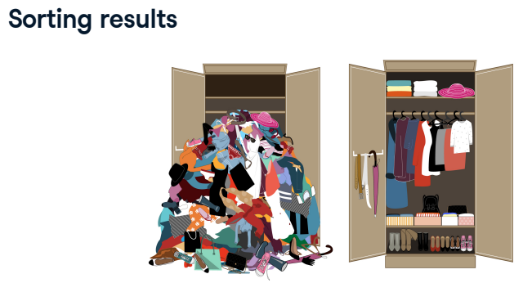

Sorting results means we want to put our data in a specific order. It's another way to make our data easier to understand by quickly seeing it in a sequence. Let's say we wanted to extract our three longest coats; if our closet were messy, it would take a long time to find. However, if we sorted our closet by garment type and length, we could quickly grab them!

## 3. ORDER BY

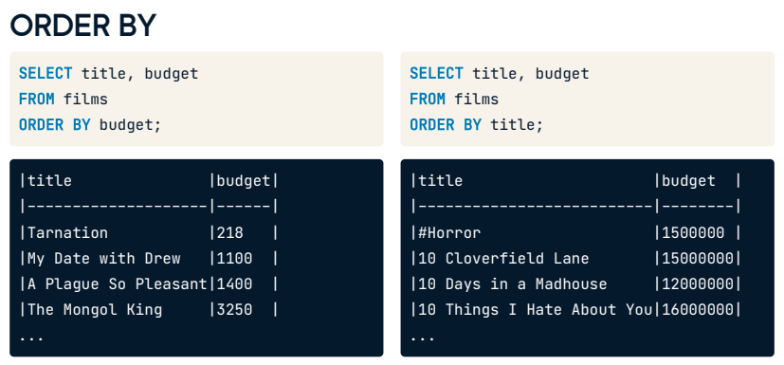

In SQL, the ORDER BY keyword is used to sort results of one or more fields. When used on its own, it is written after the FROM statement, as shown here. ORDER BY will sort in ascending order by default. This can mean from smallest to biggest or from A to Z. In this case, we have one query sorting the budget from smallest to biggest and a second query sorting the titles alphabetically. Our database contains film titles that start with symbols and numbers; these come before the letter A.

## 4. ASCending

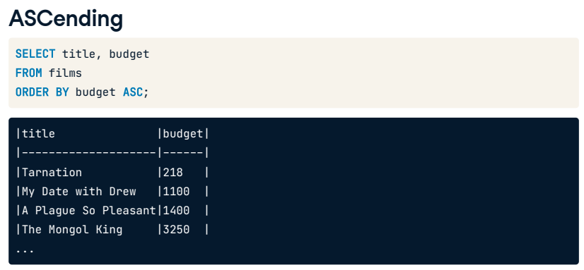

We could also add the ASC keyword to our query to clarify that we are sorting in ascending order. The results are the same, and our code is more readable.

## 5. DESCending

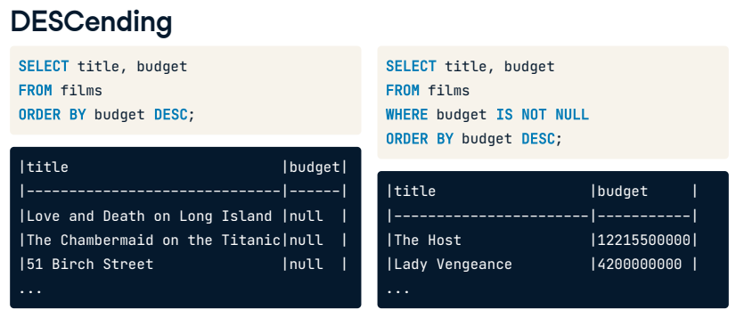

We can use the DESC keyword to sort the results in descending order. This query gives us the film titles sorted by budget from biggest to smallest. However, our data contains a lot of null values. We can add a WHERE clause before ORDER BY to filter the budget field for only non-null values and improve our results.

## 6. Sorting fields

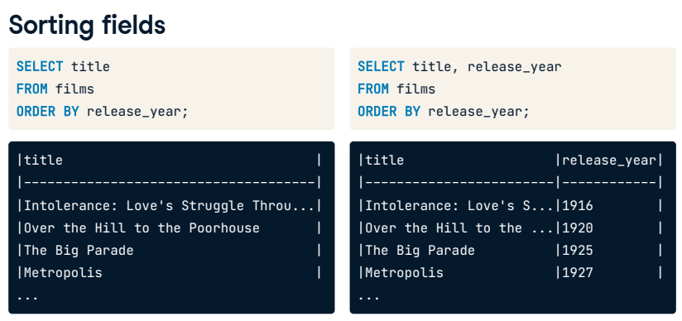

Notice that we don't have to select the field we are sorting on. For example, here's a query where we sort by release year and only look at the title. However, it is a good idea to include the field we are sorting on in the SELECT statement for clarity.

## 7. ORDER BY multiple fields

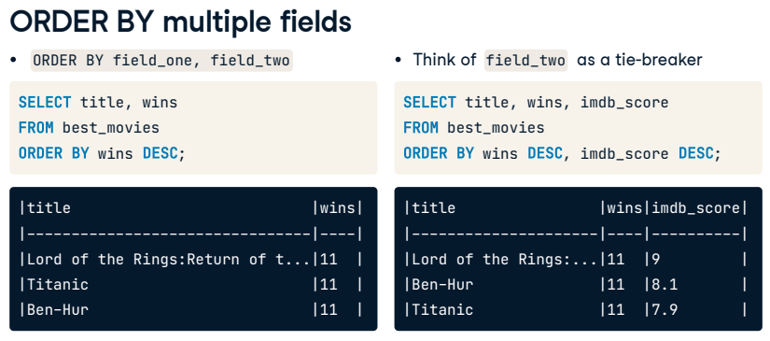

ORDER BY can also be used to sort on multiple fields. It will sort by the first field specified, then sort by the next, etc. To specify multiple fields, we separate the field names with a comma. The second field we sort by can be thought of as a tie-breaker when the first field is not decisive in telling the order. Here is an example. Let's say we wanted to find the best movie. In the first query, we are only sorting the films by the number of Oscar wins and getting a tie. We can break that tie by adding a second sorting field by seeing which film has the most wins and the highest imdb_score.

## 8. Different orders

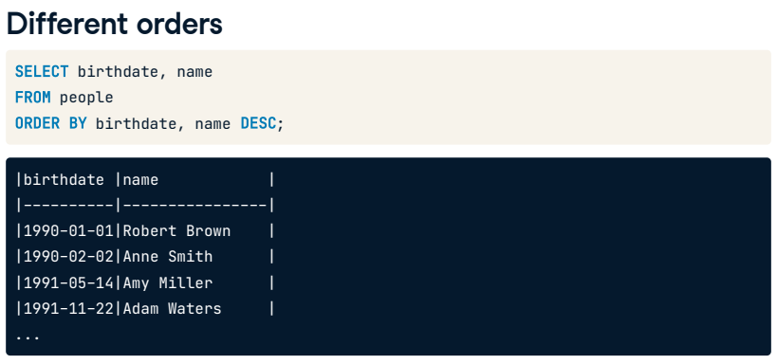

We can also select a different order for each field we are sorting. For example, here, we are sorting birthdate in ascending order and name in descending order.

## 9. Order of execution

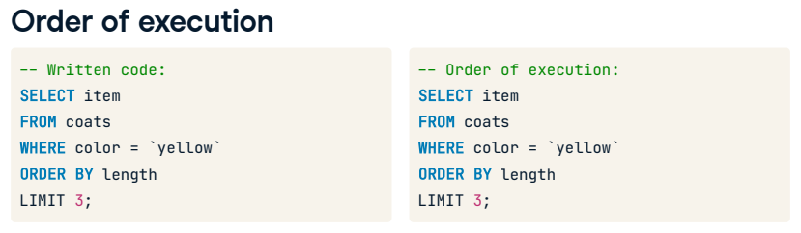

ORDER BY falls towards the end of the order of execution we already know, coming in just before limit. The FROM statement will execute first, then WHERE, followed by SELECT, ORDER BY, and finally, LIMIT.

## 10. Let's practice!

Time to practice our new sorting skills!

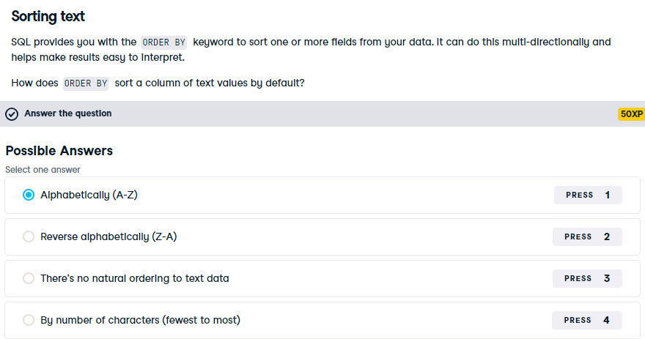

Correct! Because ascending is the default, indicating ASC is helpful for clarity but not required!.

## Exercise

# Sorting single fields

Now that you understand how ORDER BY works, you'll put it into practice. In this exercise, you'll work on sorting single fields only. This can be helpful to extract quick insights such as the top-grossing or top-scoring film.

The following exercises will help you gain further insights into the film database.

## Instructions

* + Select the name of each person in the people table, sorted alphabetically.
  + Select the title and duration for every film, from longest duration to shortest.

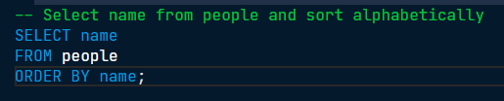

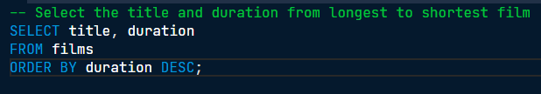

Superb sorting! ORDER BY is another simple yet effective way to gain intelligence about your business and data. You now know how to extract your best and worst-performing assets with only a few lines of code.

## Exercise

# Sorting multiple fields

ORDER BY can also be used to sort on multiple fields. It will sort by the first field specified, then sort by the next, and so on. As an example, you may want to sort the people data by age and keep the names in alphabetical order.

Try using ORDER BY to sort multiple columns.

## Instructions

* + Select the release_year, duration, and title of films ordered by their release year and duration, in that order.
  + Select the certification, release_year, and title from films ordered first by certification (alphabetically) and second by release year, starting with the most recent year.

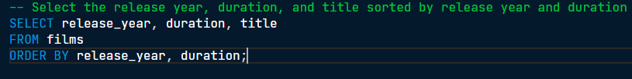

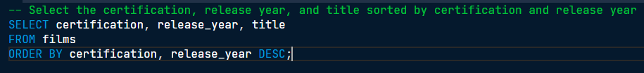

Nicely done! The second column you order on only steps in when the first column has been ordered.